Software Development project - Hangman

Mattias Ruljeff

Rulles Hack

|  |  |
| --- | --- |
| **Project name** | Hangman |
| **Revision** | 7 |
| **Project ID** | 1 |
| **Project manager** | Mattias Ruljeff |
| **Main Client** | High School‘s with programming orientation |
| **Key stakeholders** | Developer |
| **Executive Summary** | For teachers teaching programming and students who wants to learn programming in an easy and fun way |

Content

1. Revision History 3

2. Vision 4

3. Project plan 5

Introduction 5

Justification 5

Stakeholders 5

Resources 5

Hard- and Software Requirements 5

Overall Project Schedule 5

Scope, Constraints, and Assumptions 6

4. Iterations 7

Iteration 1 7

Iteration 2 7

Iteration 3 7

Iteration 4 7

5. Risk Analysis 8

List of risks 8

Strategies 8

6. Time Log 9

7. User Cases 11

Check State Diagram 13

User Case Diagram 14

Class Diagram 15

8. Test plan for Manual Test Cases and Unit Tests 16

Manual Tests: 16

Unit tests: 16

9. Manual Test Cases 17

TC2.1 Enter a username: 17

TC2.2 Enter an empty username: 18

10. Unit Tests 19

11. Unit Test results 20

12. Test Report 21

13. Reflections 22

Reflections on the Vision 22

Reflections on the project plan 22

Reflections on the risk analysis 22

Reflections on Test 22

Reflection on final hand-in 23

# Revision History

|  |  |  |  |
| --- | --- | --- | --- |
| Date | Revision | Description | Author |
| 2020-02-03 | 1 | * Added this document. | MR |
| 2020-02-13 | 2 | * Added User Cases, iteration 2 and Check-state diagram. | MR |
| 2020-02-17 | 3 | * Changed the vision. * Added reflections on the vision, risks and the project plan. | MR |
| 2020-02-21 | 4 | * Changed the Check-state diagram, planned time for hangman-game changed to 10 hours. * Rewritten UC case 1-2-3. Added class diagram. | MR |
| 2020-03-02 | 5 | * Added test plan, test cases and test report. | MR |
| 2020-03-05 | 6 | * Added screenshots on unit tests and the results of the tests. | MR |
| 2020-03-20 | 7 | * Added time-logs for all iterations. * Added highscore in unit test. * Changed screenshots on Unit Tests and removed failed test. * Changed risk strategies. | MR |

|  |  |
| --- | --- |
| Full name of Author | |
| **Initials** | **Author name** |
| MR | Mattias Ruljeff |

# Vision

The game will be targeted to High Schools and their students, for understanding programming structures and how they can develop games in JavaScript using an IDE.

This game target is to get students interested in programming, and games are often a good way to get students engaged and excited.

This will be a good template for teachers for teaching. The teachers can inspire the students to make their custom features in the game and how to, in an easy way, implement them.

In the Hangman-game, a user should guess a given word, letter by letter. It shall be a game that the user thinks is worth spending time with, being easy to get started playing with via the menus, that shall be minimal in choices that the user can make. The scoreboard at the end of the game will give the user motivation to play the game repeatedly.

# Project plan

## Introduction

A game of hangman. Played by a user in the computer console window.

The user shall be able to insert a user-name.

The animation-steps of the hangman-game are:

1. The ground and vertical pole.
2. The horizontal pole.
3. The supporting pole for the horizontal pole.
4. The rope.
5. The head.
6. The torso.
7. The arms.
8. The legs.

The user will be given eight chances to guess the letters in the word.

When the user loses, a scoreboard will be presented and the user will be asked if he/she wants to play again.

## Justification

* Hangman game will be a good teachers-tool to learn students how to program, use the console window, use Gitlab to save project-files and download project-files.

## Stakeholders

* Development team, high Schools, teachers and students.

## Resources

* Sommerville software engineering.
* Videos in 1DV600 course-page.
* An IDE of choice (preferable Visual Studio Code), Gitlab and Gitbash.

## Hard- and Software Requirements

* A computer.
* An IDE, GitLab and Gitbash.

## Overall Project Schedule

* 6 (Complete assignment 1)
* 9 (Complete assignment 2)
* 11 (Complete assignment 3)
* 12 (Submit complete project)

## Scope, Constraints, and Assumptions

**Scope**:

* The game will initially not be connected to any database.
* The game will be playable from the start. The teacher or the students will be able to modify and add functionality to the game.

**Constraints**:

* The game will only be playable in the terminal window, and will not be a stand-alone app.
* The user must have all the files containing the game and an IDE of choice.

**Assumptions**:

The project will assume that the user knows how to use Visual Studio Code (or any similar IDE) to start the game via the console window. The user knows how to install Node.js latest version and the packages that are included in the game.

# Iterations

Included parts:

* Read Software engineering.
* Create Hangman-game.
* Create documentation.
* Plan iterations.

## Iteration 1

* Create documentation.
* Start to build the Hangman-game. Add all necessary files for the project.
* Read chapters 2, 3, 22 and 23.
* Watch video-lectures 2 and 3.

## Iteration 2

* User case diagrams.
* User cases.
* Class diagram.
* Check-state diagram.
* Introduce more functionality to the game.
* Read chapters 4, 5, 6, 7, 15 and 20.
* Watch lectures 4, 5, 6, 7 and 8.

## Iteration 3

* Game-testing.
* Test plan.
* Test Cases, manual and unit tests.
* Coding Unit tests.
* Hangman unicode-array.
* Read chapter 8.
* Watch lectures 9, 10 and 10.5.

## Iteration 4

* Complete the game:
  + Add lines in the console where there shall be letters.
  + Create a check for the word “quit” to exit the game while guessing letters in the word.
  + Create the scoreboard.
* Fix issues from earlier iterations.
  + Time-log assignment 2
  + User Case 2 – Add trigger, add more steps in UC2 main scenario.
  + Fix State Machine. Change state-names and change action-symbols.
  + Rewrite Class Diagram.
* Complete the report.

# Risk Analysis

## List of risks

|  |  |  |  |  |
| --- | --- | --- | --- | --- |
| Risk | Affect | Description | Probability | Effects |
| Hardware failure | Project | If the computer/hard-drive crashes | Low | Catastrophic |
| Sickness | Project and product | If I get sick and can’t go to school | Moderate | Serious |
| Size underestimate | Project and product | If the added features are too complicated/hard to integrate | Moderate | Serious |
| Requirement change | Project and product | If the product specifications change | Moderate | Tolerable |

## Strategies

|  |  |
| --- | --- |
| Risk | Strategy to minimize impact of risk |
| Hardware/software | Save all the files to Gitlab. Backup-computer available |
| Sickness | Work from home in case of sickness |
| Size underestimate | Skip extra functions |
| Requirement change | Build modules that can easily be modified |

# Time Log

|  |  |  |  |  |  |
| --- | --- | --- | --- | --- | --- |
| Tasks | Planned time (hours) | Actual time (hours) | Starting date | Latest update | End date |
| Iteration 1 | | | | | |
| **Create document** | 4 | 5 | 2020-02-28 09:00 | 2020-02-03 13:00 | **2020-02-03 13:00** |
| **Start creating Hangman**  **Game** | 5 | 3 | 2020-02-28 09:00 | 2020-02-03 13:00 | **2020-02-03 13:00** |
| **Education and research** | 12 | 16 | 2020-02-28 09:00 | 2020-02-03 13:00 | **2020-02-03 13:00** |
| Iteration 2 | | | | | |
| **Use Case diagram** | 1 | 1 | 2020-02-10 09:00 | 2020-02-24 16:00 | **2020-02-24 16:00** |
| **User Cases** | 1 | 1 | 2020-02-10 09:00 | 2020-02-24 16:00 | **2020-02-24 16:00** |
| **Class Diagram** | 1 | 0,5 | 2020-02-10 09:00 | 2020-02-24 16:00 | **2020-02-24 16:00** |
| **Check-state Diagram** | 1 | 1 | 2020-02-10 09:00 | 2020-02-24 16:00 | **2020-02-24 16:00** |
| **Adding more functions**  **to Hangman game** | 3 | 2 | 2020-02-10 09:00 | 2020-02-24 16:00 | **2020-02-24 16:00** |
| **Education and research** | 16 | 18 | 2020-02-10 09:00 | 2020-02-24 16:00 | **2020-02-24 16:00** |
|  |  |  |  |  |  |
| **Tasks** | Planned time (hours) | Actual time (hours) | Starting date | Latest update | End date |
| Iteration 3 | | | | | |
| **Project plan** | 10 | 9 | 2020-02-03 11:00 | 2020-02-17 14:30 | **2020-02-17 14:30** |
| **Hangman-game** | 10 | 4 | 2020-01-31 15.30 | 2020-02-21 14:00 | **2020-02-21 14:00** |
| **Writing tests** | 10 | 7 | 2020-03-02 09:00 | 2020-03-05 20:46 | **2020-03-05 20:46** |
| **Testing** | 5 | 3 | 2020-03-04 09:00 | 2020-03-05 20:46 | **2020-03-18 14:00** |
| Iteration 4 | | | | | |
| **Complete Hangman Game** | 2 | 4 | 2020-03-18 15:00 | 2020-03-20 15:30 | **2020-03-20 15:30** |
| **Fix Issues from earlier**  **Iterations** | 4 | 4 | 2020-03-18 09:00 | 2020-03-18 14:00 | **2020-03-18 14:00** |
| **Complete the report** | 3 | 7 | 2020-03-18 09:00 | 2020-03-20 22:00 | **2020-03-20 22:00** |
| **Total time** | 113 | 85,5 |  |  |  |

# User Cases

|  |  |
| --- | --- |
| UC 1 Start Game | |
| Preconditions: | None |
| Post conditions | The game menu is shown |
| Main Scenario | |
| 1. Starts when the User starts a session of Hangman-game. 2. The Systems presents the main menu, presenting a welcome message, the options to play or to quit the game. 3. The User starts the game. | |
| Alternative scenarios | |
| 1. The User quits the game. 2. The System prompts if the User wants to quit the game. (See UC 3) | |
| UC 2 Play the game | |
| Preconditions: | * User has chosen to play the game. * The game must be started. |
| Post conditions | The UC 1 or UC 3 is triggered |
| Main Scenario | |
| 1. The User enters a name. 2. The System displays the word-lines and prompts the User to enter a letter. 3. The User enters a letter. 4. Repeat steps 2-3 until the User has guessed the whole word. 5. The System prompts if the User wants to play again. (return to UC 1) | |
| Alternative scenarios | |
| 1. The user doesn’t enter a name, the system asks the user to enter a name. 2. The system detects that the letter is wrong, creates parts of the hanged man and presents it to the user. 3. The user guessed wrong 8 times, loses the game. (See UC 3) 4. The system prompts if the user wants to play again. 5. The system detects that the letter is wrong, creates parts of the hanged man and presents it to the user. 6. The user enters “quit”. 7. The System prompts if the User wants to quit to the main menu. 8. The User confirms (see UC 3) | |

Continues on the next page.

|  |  |
| --- | --- |
| UC 3 Quit the game | |
| Preconditions: | The game session is running |
| Post conditions | The game session is terminated |
| Main Scenario | |
| 1. Starts when the User wants to quit the game, win or lose. 2. The System prompts if the user wants to quit the game. 3. The User confirms. 4. The System terminates. | |
| Alternative scenarios | |
| 1. The User does not confirm. 2. The System returns to UC 1 start game | |

## Check State Diagram

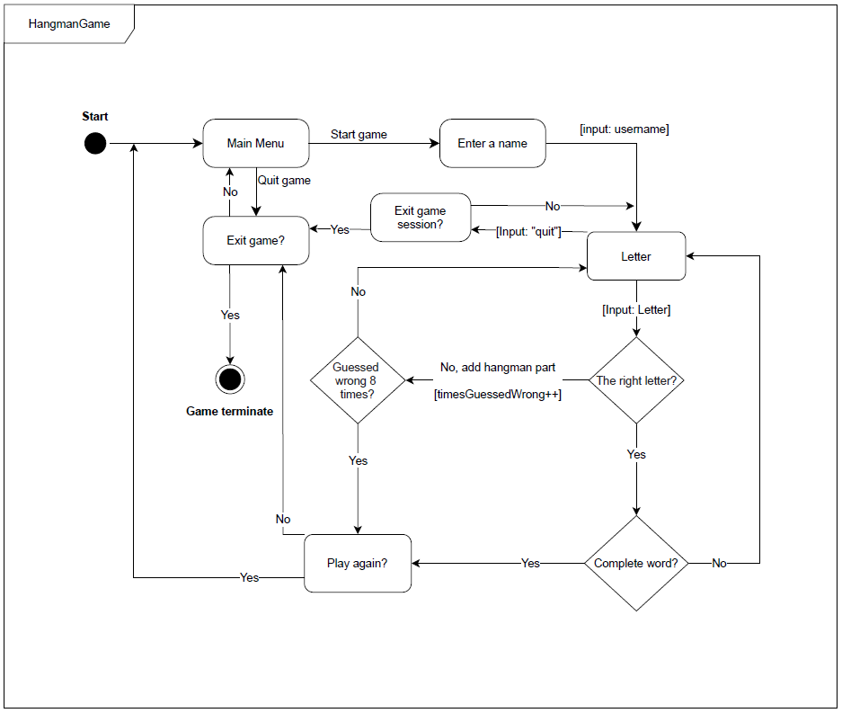

|  |
| --- |
| This diagram has been chosen to show the programmers and the final customer the flow and logic of the game. It is an easy way for everyone, not only people with programming experience, to show how the logic in the game works. |

## User Case Diagram

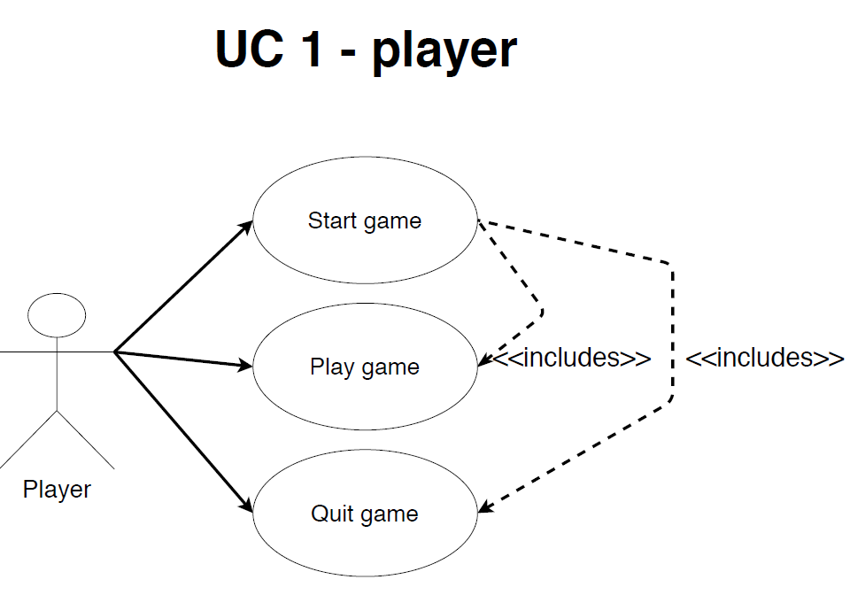

|  |
| --- |
| This diagram is an easy way to show witch User cases are used and how they are connected (includes) to each other. |

## Class Diagram

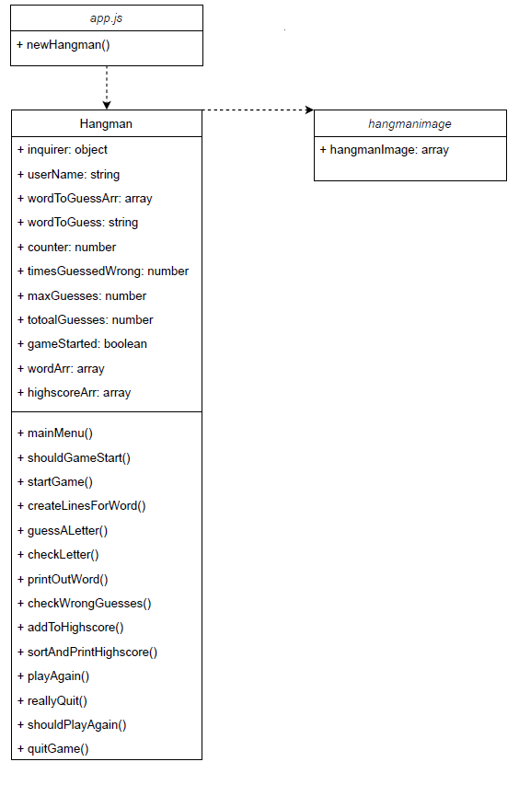

|  |
| --- |
| This is mostly for the programmers. It shows witch parts of the game belongs to which class/file.  Gives a quick overview of the methods and the variables. |

# Test plan for Manual Test Cases and Unit Tests

The methods that will be tested in the manual test is UC2 and the Unit Test will contain “shouldGameStart”, “checkLetter”, “checkWrongGuesses” and “highscore”. All these methods are critical for the game functionality.

## Manual Tests:

* The test TC1 tests the systems for the ability to retrieve username input and save that username. It’s chosen because of the high score-implementation. It will be tested as a manual static test.
* Manual inspection of the code to find bugs.

## Unit tests:

* **shouldGameStart** – Tests if the input from the user is the right input to start the game.
* **checkLetter** – Tests if the letter that the user inputs when guessing the letter in the word. Checks if it is the correct letter according to the letter in the word at a given index.
* **checkWrongGuesses** – Checks how many times the user has guessed the wrong letter in the word. If the guesses are exceeding the maximum guesses allowed, the game should prompt that the user has lost the game.
* **highscore** – Checks if the user is added to the high score and if the high score prints out in the console.

|  |  |  |
| --- | --- | --- |
| Task | Planned time | Actual time |
| Manual test Case | 1 h | 1 h |
| Writing unit tests | 1 h | 4 h |
| Unit testing | 30 min | 20 min |
| Running manual tests | 1 h | 10 min |
| Code inspection | 1 h | 40 min |
| Test report | 1 h | 30 min |

# Manual Test Cases

## TC2.1 Test if username can be entered:

Use case: UC2 play the game.

Scenario: The user will enter the name “Johan”. The system will prompt the entered username. (The user uses the keyboard to navigate)

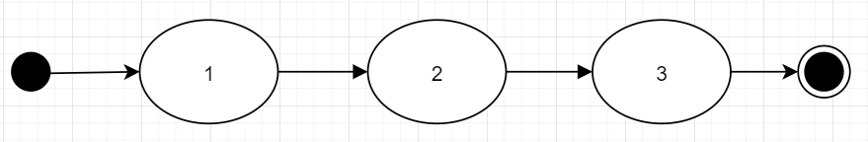

The main scenario of UC2 is tested if the username is stored.

Preconditions:

* The game must be started.
* The user must have chosen to play the game.

**Test steps**

* The System prompts the user to insert a username.
* The user enters the name “Johan” and press enter to confirm the username.
* The system displays “Welcome Johan” and prompts the user to enter a letter.

**Expected results**

* The username is saved, and the user is prompted to enter a letter.

## TC2.2 Test error-handling if no username is provided:

Use case: UC2 play the game.

Scenario: The user shall not enter a name as the username. The system prompts an error message. (The user uses the keyboard to navigate)

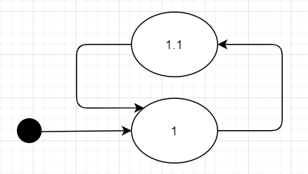

The main scenario of UC2 is tested if the systems prompts an error if the user does not enter a username.

Preconditions:

* The game must be started.
* The user must have chosen to play the game.

**Test steps**

* The System prompts the user to insert a username.
* The user presses enter to confirm the username.

**Expected results**

* The system prompts the user to enter a username with at least one letter or more.

# Unit Tests

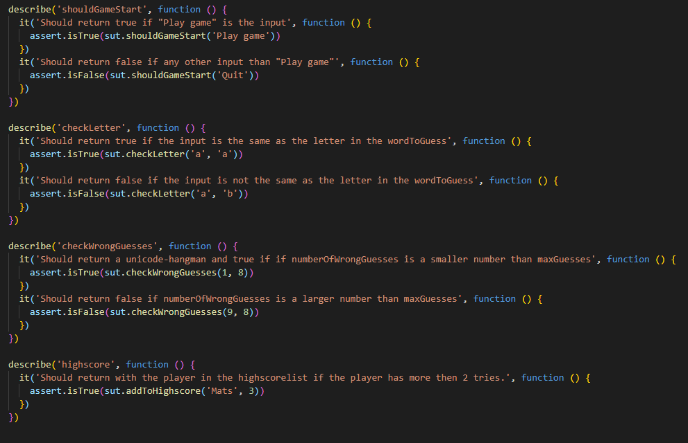

# Unit Test results

# Test Report

|  |  |
| --- | --- |
| Manual Test Cases | UC2 |
| TC2.1 | 1/OK |
| TC2.2 | 1/OK |
| COVERAGE AND SUCCESS | 2/OK |

|  |  |
| --- | --- |
| Unit Test | UC2 |
| shouldGameStart | 1/OK |
| checkLetter | 1/OK |
| checkWrongGuesses | 1/OK |
| highscore | 1/OK |
| COVERAGE AND SUCCESS | 4/OK |

# Reflections

## Reflections on the Vision

The vision is hard to come up with when having a project that contains such a small game.

To motivate the team that develops the game, and to have a good vision is necessary, also as a selling point to the customer!

The vision should reflect the goal of the development, the things that will make the game special, to make the development teamwork in the same direction for the same goal! That is what I wanted to accomplish with my vision.

The task also included a special feature. I chose to give the game a scoreboard so that the user wants to come back and beat the best player. That is my way of giving the user a “goal” to the game, be the best player.

## Reflections on the project plan

The project plan was easier to write than the Vision because the project plan is more how the game is meant to be structured so that the developers of the game and the stakeholders in the project plan knows how the final product shall work. It was harder to find good ways of writing the Scope, Constraints, and Assumptions.

## Reflections on the risk analysis

The risks in this project are not many. This project is a small project and the hardware and software are not extensive. The changing of requirements is a risk that is more likely to happen, but that may be because the development team comes up with additional functions to make the game more playable and interesting.

Risk in a project is the hardest thing to plan. It is always hard to know how to avoid risks, but if a project has risk management plans it is less likely that the risk will make much damage to the project and take too long time. It is also easier to re-plan if something happens and the project have a plan-B.

## Reflections on Test

I found the Unit test to be the hardest part to write. The first tests I wrote were too simple and only tested if the return was an Array or String. After asking how to make useful tests and how to write better code that could be tested, I wrote better tests that tested easy input and easy output.

The manual test cases were easier to find methods to test because the tester can interact via the console and use the input to control and test the application.

## Reflection on final hand-in

In this iteration, the focus has been on fixing the feedback from earlier iterations and completing the Hangman Game.

The completion of the game was not hard, but it took a while to make the final implementations.

The hard part was understanding how to complete the final project and include all other iterations in a good way.